Project Design Phase-II
Data Flow Diagram & User Stories

Date | 30 September 2026
Team ID | SWTID-2026-2306
Project Name | AI StudyBuddy API – Deliver Intelligent, Personalized Study Assistance
Maximum Marks | 4 Marks

Data Flow Diagrams:
A Data Flow Diagram (DFD) is a traditional visual representation of the information flows within a system. A neat and clear DFD can depict the right amount of the system requirement graphically. It shows how data enters and leaves the system, what changes the information, and where data is stored.
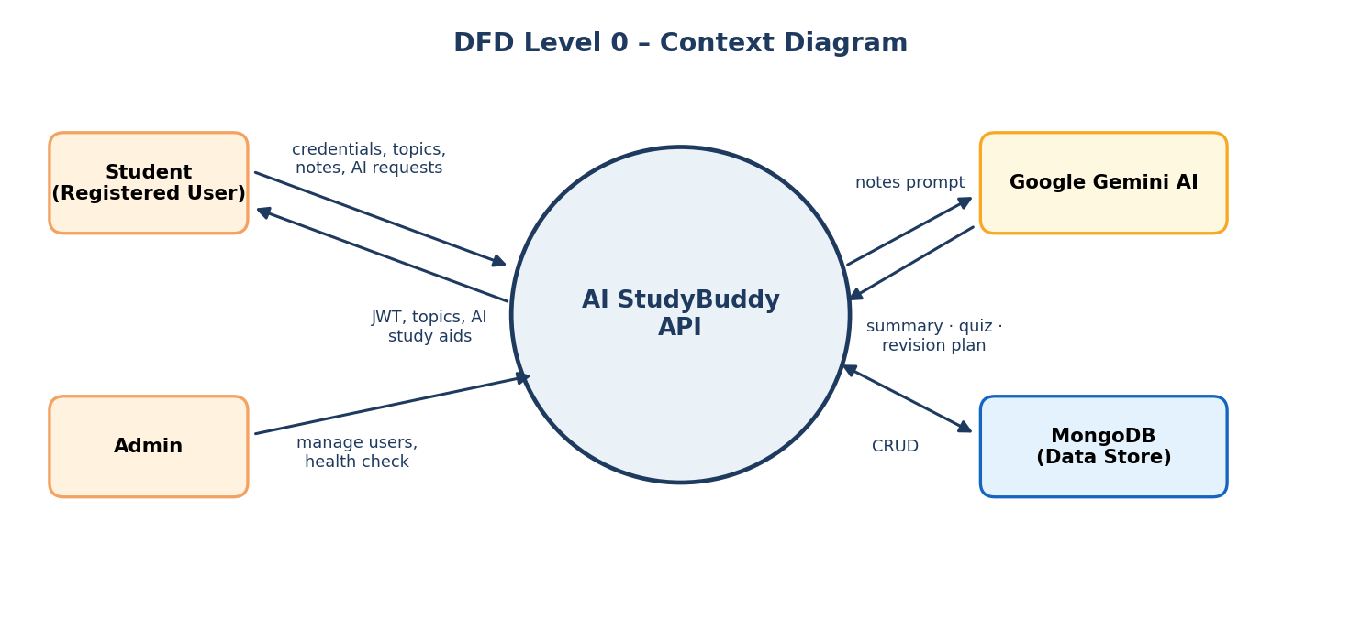
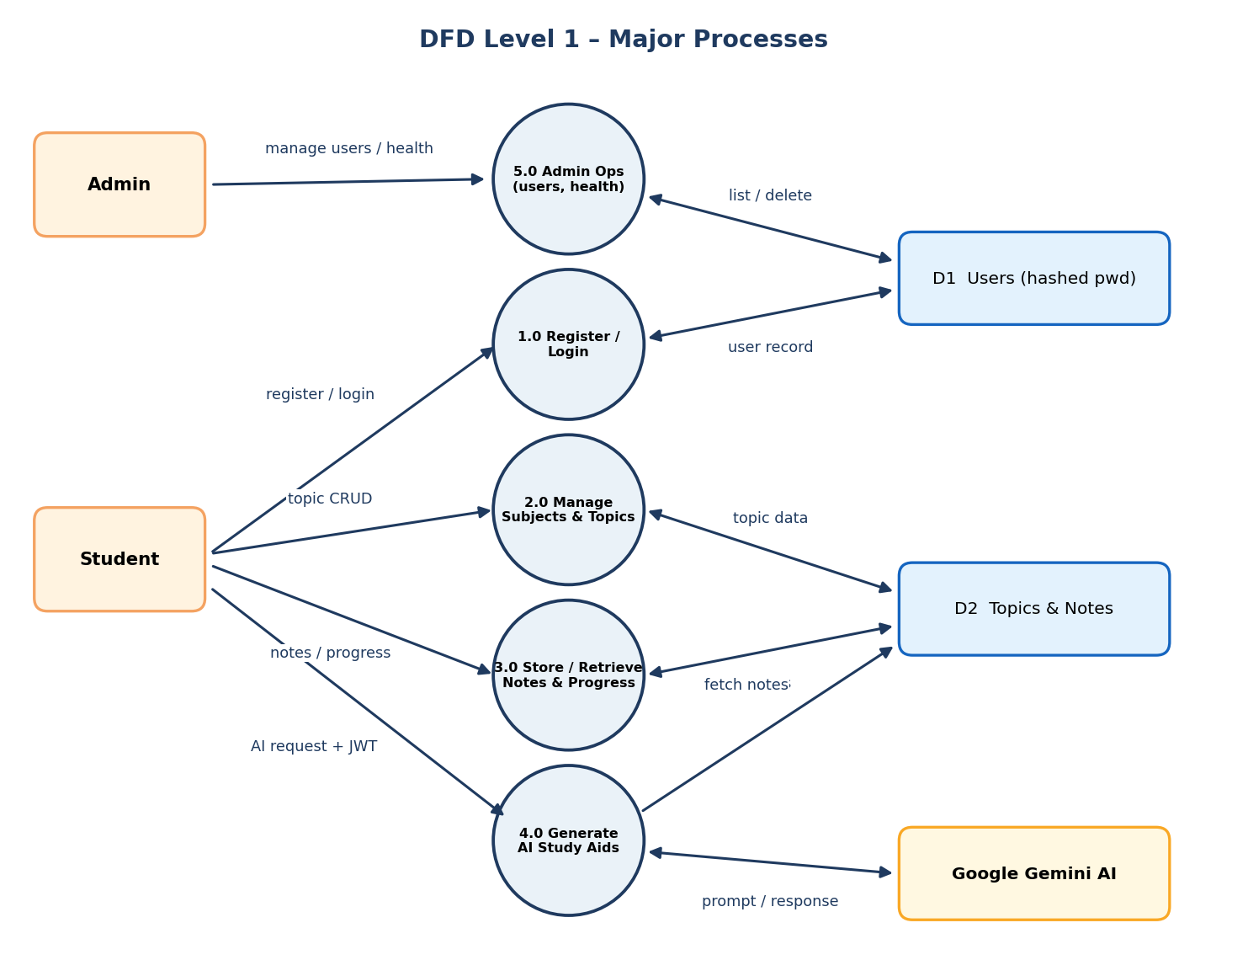

User Stories
Use the below template to list all the user stories for the product.
User Type | Functional Requirement (Epic) | User Story Number | User Story / Task | Acceptance criteria | Priority | Release
Student (Registered User) | User Registration | USN-1 | As a student, I can register by entering my name, email and password so that I can use the application. | Account is created and a 201 response is returned; password is stored hashed | High | Sprint-1
 |  | USN-2 | As a student, I can log in with my email and password to receive a JWT token. | Valid credentials return a JWT with 200; invalid password returns 401 | High | Sprint-1
 | Subject & Topic Management | USN-7 | As a student, I can create a subject and a study topic so that my material is organised. | Topic is saved against my user and returns 201 | High | Sprint-2
 |  | USN-8 | As a student, I can view, update and delete my topics. | Only my topics are listed; updates and deletions persist correctly | High | Sprint-2
 | Study Notes | USN-11 | As a student, I can save and retrieve notes and progress for a topic. | Notes and progress are stored and returned for that topic | High | Sprint-2
 | AI Study Aids | USN-15 | As a student, I can request an AI summary of my topic notes to understand them quickly. | Gemini-generated summary is returned in plain language | High | Sprint-3
 |  | USN-16 | As a student, I can get practice questions and revision recommendations for a topic. | Quiz questions and a personalised revision plan are returned | High | Sprint-3
 |  | USN-18 | As a student, I still receive a study response even if the AI key is missing or fails. | Fallback text response is returned instead of an error | High | Sprint-3
Admin | Admin Management | USN-20 | As an admin, I can view all registered users. | Admin token returns the user list; non-admin token is refused | Medium | Sprint-4
 |  | USN-21 | As an admin, I can delete or suspend a user account. | User is removed / suspended and confirmation is returned | Medium | Sprint-4
 |  | USN-22 | As an admin, I can check API and service health. | Health status of API, database and AI service is returned | Medium | Sprint-4
Guest User | Public Access | USN-23 | As a guest, I can access public endpoints for general study tips and API information without an account. | Public endpoints respond without a token | Low | Sprint-4

